Comparison Analysis between Traditional and LowCode

Date: 22/07/2026
VISHAAL S

Aim :
To study the differences between the Traditional Software Development approach and the Low-Code Development approach, and understand their development process, advantages, and applications.
Introduction to Traditional Approach :
The Traditional Approach is the conventional method of software development where applications are built by writing code using programming languages such as Java, Python, or C#. Developers manually design, code, test, and deploy the application. This approach provides greater flexibility and control but requires more time, skilled developers, and higher development costs.
Introduction to Low Code Approach :
The Low-Code Approach is a modern software development method that uses visual interfaces, drag-and-drop components, and minimal hand-written code to build applications. It enables faster application development, reduces coding effort, and allows both professional developers and non-technical users (citizen developers) to create applications efficiently.
Diagram for stages in Traditional and Low Code :
Traditional Development Process :
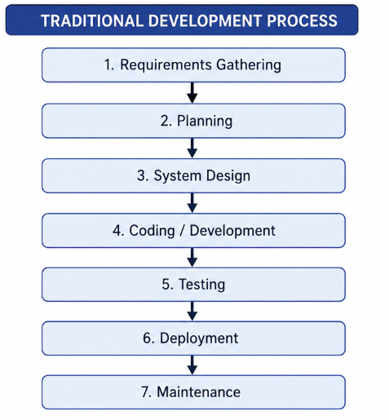

Low Code Development Process :
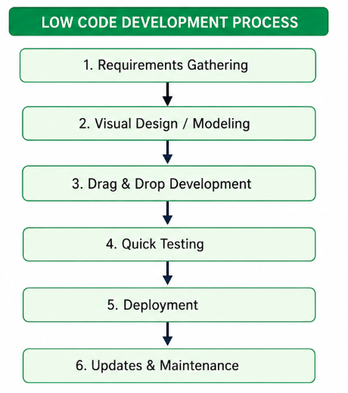
Compare Traditional and Low Code :
Traditional Approach | Low-Code Approach
Requires extensive manual coding. | Requires little or no manual coding.
Development process is time-consuming. | Development process is faster.
Requires skilled software developers. | Can be used by developers and business users.
High development and maintenance cost. | Lower development and maintenance cost.
Better suited for large and complex applications. | Best suited for business applications and rapid development.
Every feature is coded from scratch. | Uses pre-built components and drag-and-drop tools.
Testing and deployment take more time. | Testing and deployment are quick and simple.
Modifying or updating the application is difficult. | Applications can be updated easily and quickly.
Longer project delivery time. | Shorter project delivery time.
Greater flexibility for customization. | Limited customization compared to traditional development.
Result:
The Traditional and Low-Code development approaches were studied and compared successfully. It was observed that Low-Code development enables faster application development with less coding, while the Traditional approach offers greater flexibility for complex applications.

